# **Sales Insights Dashboard for Insurance Company**

## **Project Overview**

This project focuses on building a **Sales Insights Dashboard** for a fictional insurance company. The primary objective is to deliver real-time, data-driven insights on sales performance, customer behavior, and financial outcomes. We leverage **Snowflake**, **DBT**, **Tableau**, and **Apache Airflow** for seamless data processing and visualization, empowering business decisions with timely insights.

## **Problem Statements**

The Sales Director is keen to analyze the company's performance across various criteria:

* **Product Performance**: Which insurance products are the top performers?
* **Customer Segmentation**: Who are the primary buyers of each product?
* **Sales Trends & Forecasting**: What does the future hold for sales?
* **Geographical Insights**: How do sales vary by region?
* **Agent Performance & Claim Status**: What’s driving growth, and how are profit margins?

The goal of this project is to show how data can guide key business decisions.

## **Technologies Used**

* **Snowflake**: Raw data storage and query execution.
* **DBT**: Data transformation for building analytical models.
* **Apache Airflow**: Workflow orchestration and automation.
* **Tableau**: Data visualization for reporting and insights.
* **GitHub**: Version control and collaboration.

## **Certifications**

* **Data Visualization with Tableau** – Cognizant LED Training
* **Snowflake Essentials for Data Engineering** – Snowflake
* **DBT** – Udemy
* **Apache Airflow** – LinkedIn Learning
* **GitHub** – YouTube Tutorials

## **Workflow**

1. **Data Ingestion**: Import local data into Snowflake (raw data layer).
2. **Transformation**: Use DBT to run data transformations and create analytical models.
3. **Data Views**: Generate final data models in Snowflake.
4. **Orchestration**: Schedule workflows with Apache Airflow.
5. **Visualization**: Build interactive dashboards using Tableau.

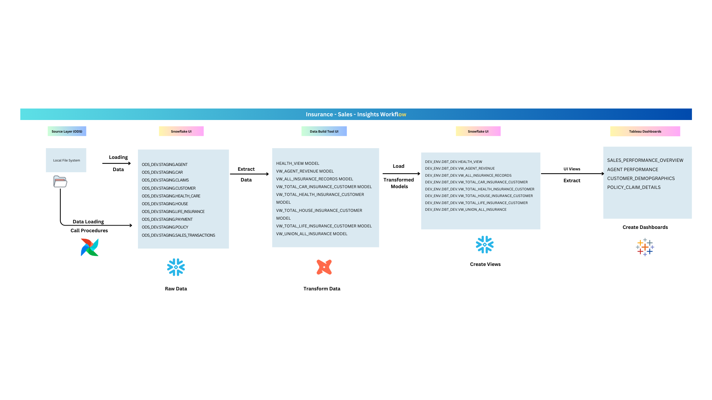**Key Insights Explored**

* Top-performing insurance products
* Customer segments most likely to purchase
* Sales forecasts for upcoming quarters
* Regional sales performance
* Revenue and profit margins

## **Approach - Project Planning**

1. **Purpose**: To provide the sales team with automated insights, reducing manual data gathering and enabling better decision-making.
2. **Stakeholders**: Sales Director, IT Team, Customer Service Team, Data & Analytics Team.
3. **End Result**: An automated dashboard providing real-time sales insights for data-driven decision-making.

## **Setup Process**

Follow these steps to set up the project:

1. **Generate Dummy Data**: Use Python's faker library to create fake data.
2. **Ingest Data**: Import the generated data into Snowflake and perform ETL (if needed).
3. **DBT Environment**: Set up a DBT environment and connect it with your Snowflake database.
4. **Apache Airflow Setup**: Install and configure Airflow locally for scheduling DAGs.
5. **Tableau Setup**: Download Tableau Public (free) or Tableau Desktop (14-day trial) to visualize data.
6. **Data Connection**: Connect Tableau to Snowflake for real-time analysis.
7. **Dashboard Creation**: Save Tableau reports as .twb or .twbx files.

## **ER Diagram**

* **Snowflake**: For raw data storage and querying.
* **DBT**: For transforming raw data into analytical models.
* **Tableau**: For visualizing insights through interactive dashboards.

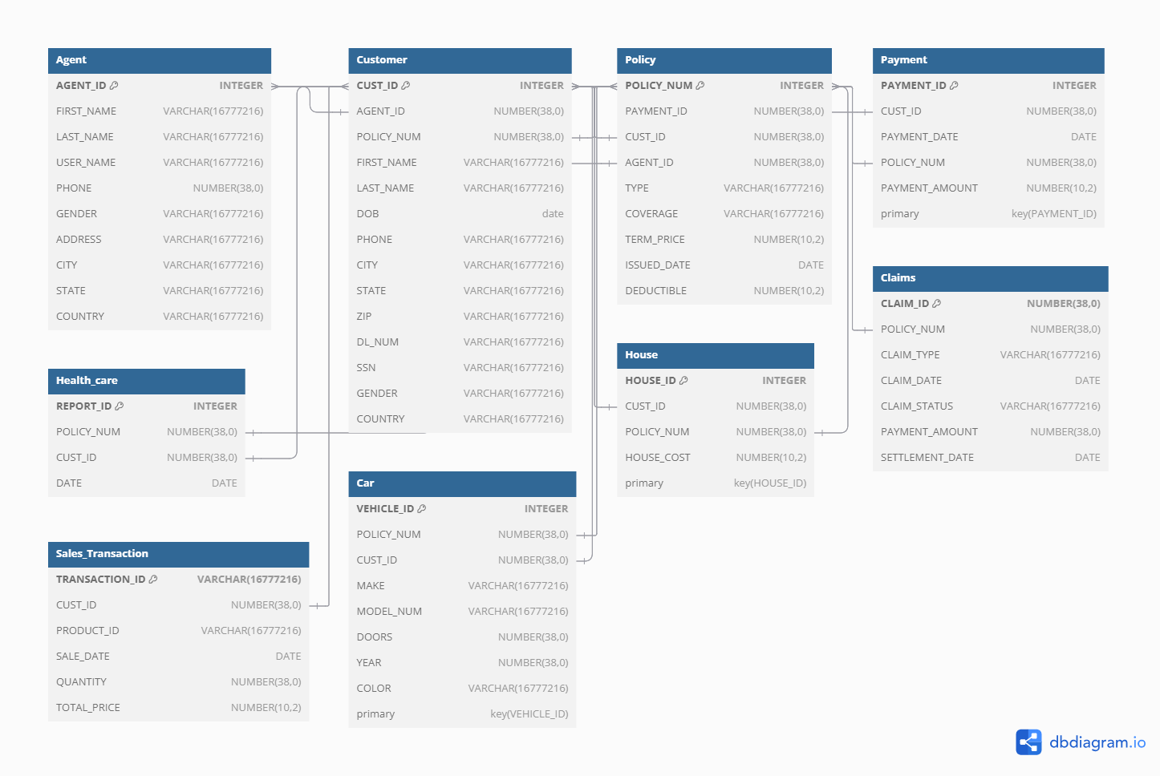

**Snowflake**

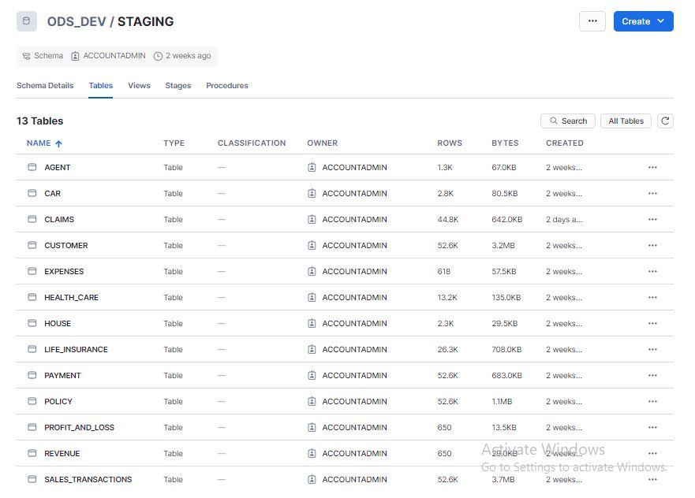

**Data Build Tool (Transform Data)**  
Creating models through DBT.  
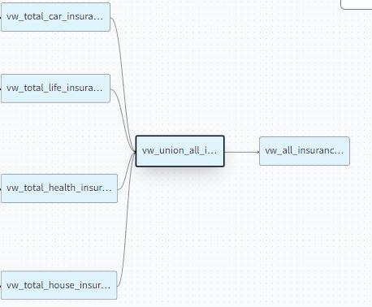

**Orchestrating Tasks Using Airflow**

* **snowflake_automate_data_copy_dag.py:** This DAG is responsible for loading data from stages into our database tables.
* **snowflake_migrate_tables_dag.py:** This DAG is used when we need to migrate all objects from the development DBT environment to the production DBT environment.
* **dbt_run_models.py:** This script runs all DBT models using the dbt run command, with all models being stored in the Snowflake database**.**

**Data Analysis Using Tableau**   
   
**Tableau Public Dashboards**: [Insurance - Sales - Insights | Tableau Public](https://public.tableau.com/app/profile/prem.shende/viz/Insurance-Sales-Insights/d1?publish=yes)

*Taking data source from Snowflake database.*

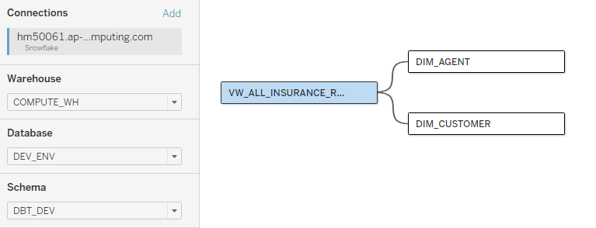

* **Master Dashboard**: Insurance Sales Insights Report.

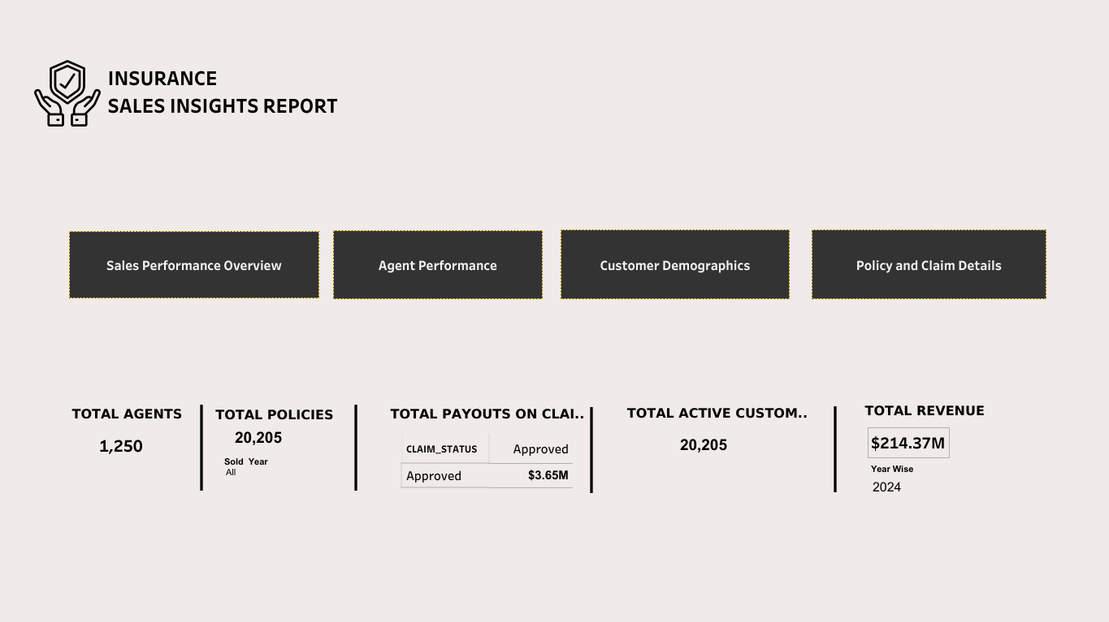

* **Sales Performance Overview Dashboard**: A Sales Performance Overview Dashboard provides a real-time snapshot of key sales metrics.

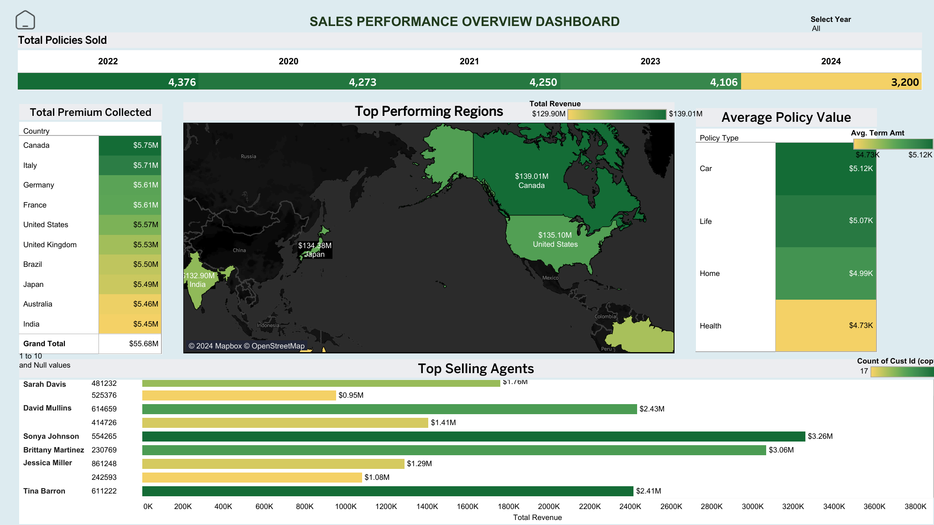

* **Agent Performance Dashboard**: Tracks agent-wise sales performance.

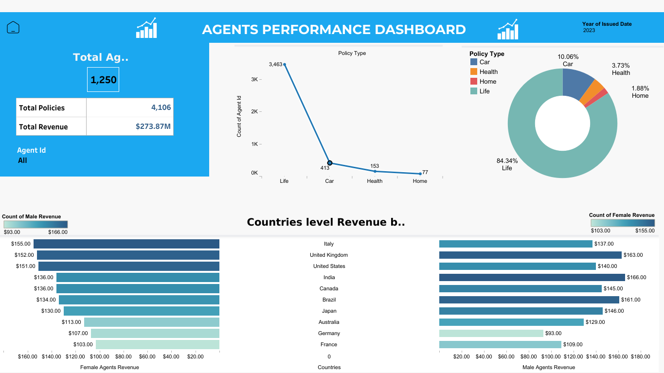

* **Customer Demographics Dashboard**: Analyzes customer profiles and behavior.

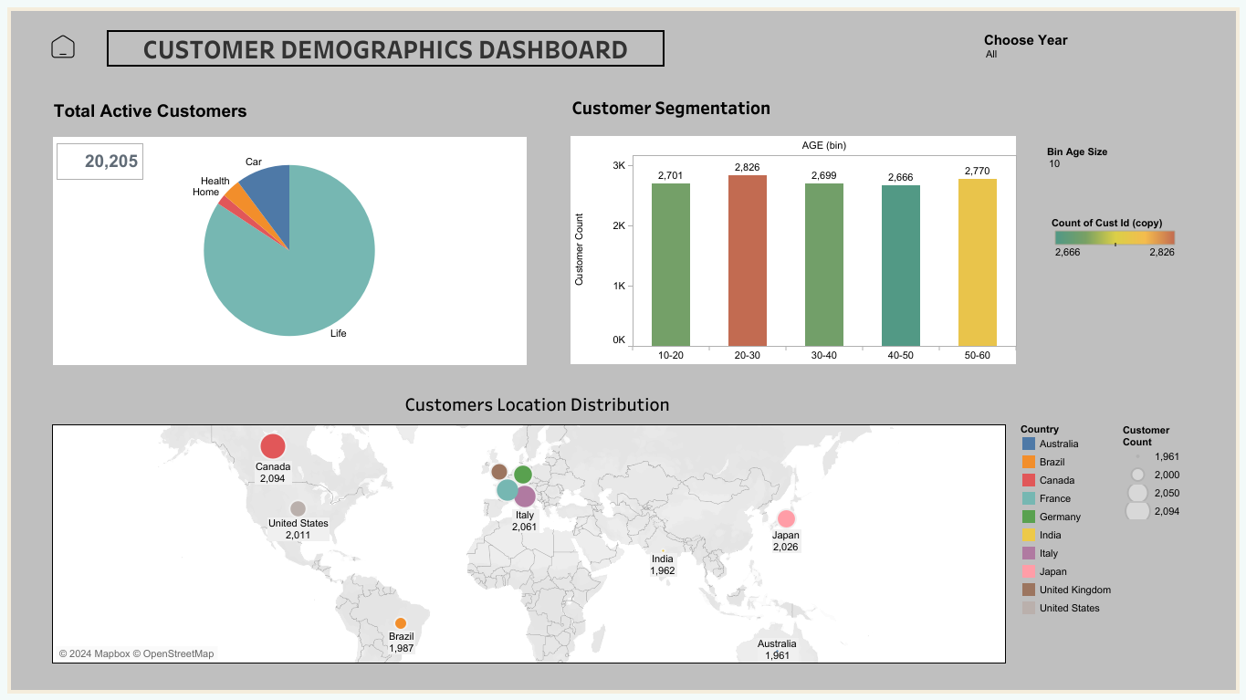

* **Policy and Claims Dashboard**: Provides insights into policy details and claim statuses.

